**7.1.5. Awareness on Ban on single Use Plastic**

**Single use plastic:**

In a move that could have significant impact in checking plastic pollution, India banned the use of 'single-use plastic' from **July 1, 2022**. According to the Plastic Waste Management Amendment Rules, 2021, the manufacture, import, stocking, distribution, sale, and use of plastic carry bags having thickness less than **75 microns** had already been banned with effect from 30 September 2021. India banned some single-use or disposable plastic products to phase out the ubiquitous material in the nation of nearly 1.4 billion people. For the first stage, it has identified 19 plastic items that aren't very useful but have a high potential to become litter and makes it illegal to produce, import, stock, distribute or sell them. The banned items include ice-cream sticks, polystyrene (thermocol), plates, cups, glasses, forks, spoons, earbuds, plastic sticks for balloons, flags, candy sticks, wrapping or packaging films around sweets boxes, invitation cards, cigarette packets, knives, stirrers, straws, trays and plastic or PVC banners. Plastic manufacturers had appealed to the government to delay the ban, citing inflation and potential job losses. Streets across towns are littered with used plastic goods that eventually choke drains, rivers and oceans and also kill animals.

**Penalties:**

Penalties for violations of the ban will probably take effect after an initial six-month period to allow people It will also ask e-commerce companies to cut back on plastic packaging that makes up nearly 40% of India's annual plastic consumption, officials say. Cheap smartphones and a surge in the number of internet users have boosted orders for e-commerce companies, such as Amazon.com Inc and Walmart Inc's Flipkart, which wrap their wares - from books and medicines to cigarettes and cosmetics - in plastic, pushing up consumption. While it is an important material for our economy, **providing multiple benefits to modern day living**, plastic can take thousands of years to biodegrade.

**Earth warming Gases:**

It takes up valuable space in landfill sites and is polluting the natural environment, having a significant impact on our oceans. A nationwide ban that includes not just the use of plastic, but also its production or importation was a "definite boost," Making plastic releases earth-warming greenhouse gases into the atmosphere and India is home to factories that make over 243,000 metric tons (268,000 U.S. tons) of disposable plastic each year. This means that reducing the manufacture and consequent waste of plastic is crucial for India to meet its target of reducing the intensity of emissions in economic activity by 45% in eight years. A recent study identified over 8,000 chemical additives used for plastic processing, some of which are a thousand times more potent as greenhouse gases than carbon dioxide. Most plastic cannot be recycled, only downgraded, and it's often incinerated or used as fuel in waste-to-energy plants, sometimes known as chemical recycling. While plastics are worth three to four times as much for fuel than as scrap, these recycling processes release more carbon dioxide into the atmosphere, adding to the greenhouse effect. Concerns are growing worldwide about plastic pollution, with a particular focus on the oceans, where nearly 50% of single-use plastic products end up, killing marine life and entering the human food chain,

**Microplastics**

plastic isn't recycled globally and millions of tons pollute the world's oceans, impact wildlife and turn up in drinking water. Scientists are still trying to assess the risks posed by the tiny bits of broken-down plastic, known as microplastics. The creaky waste management system in the country's burgeoning cities and villages means that much of this waste isn't recycled and ends up polluting the environment.

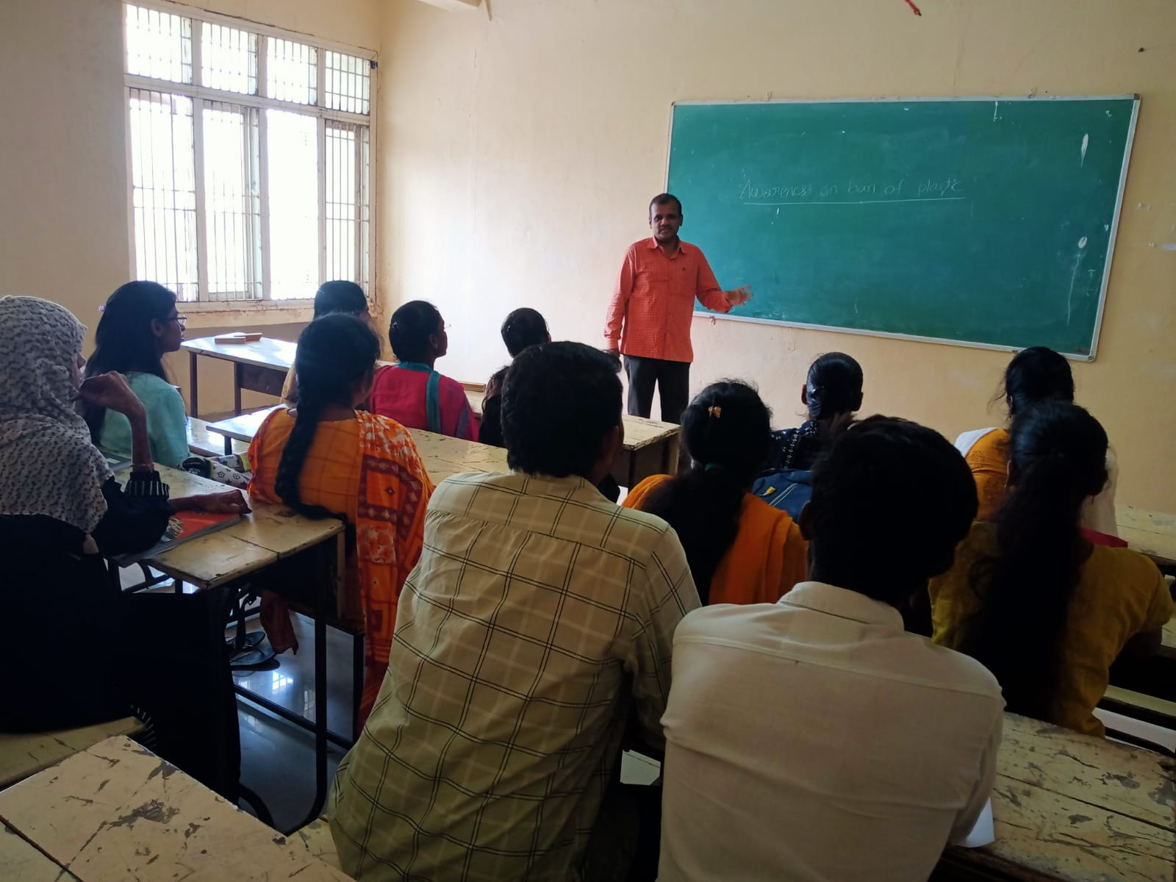

An awareness was created by Sri M. Narsimha Murthy regarding implications of Plastic.

This initiative was taken to create awareness among students and to ensure that they stop the usage of plastics. Reusable plastics can be used but not single use plastics